Chapter 1

INTRODUCTION

Overview
These days, most companies run their software using something called Kubernetes, which helps manage all the different pieces of an application. It's become the go-to solution because it works really well, but there's a catch – it's gotten incredibly complicated.
Think about it: you might have hundreds or even thousands of servers all working together, each running different parts of your applications. Everything is connected to everything else, and when one thing changes, it can affect dozens of other components in ways you didn't expect.
Modern applications are also constantly changing – they scale up and down automatically based on demand, new versions get deployed regularly, and different services are constantly talking to each other. With all this activity, there are so many things that can go wrong: servers running out of memory, network connections failing, storage getting full, or applications just crashing for mysterious reasons.
The traditional way of monitoring systems – setting up alerts that go off when something crosses a certain threshold – just isn't enough anymore. By the time your monitoring system starts screaming, the damage is often already done. Your users are experiencing problem.
Here's where things get exciting. We now have the technology to be smarter about this. Instead of just reacting to problems after they happen, we can use AI and machine learning to actually predict when things might go wrong. By looking at patterns in how our systems behave over time, we can spot the warning signs early and fix issues before they become real problems.
This shift from "Oh no, something broke, let's fix it" to "Hey, this might break soon, let's prevent it" could completely change how we manage our technology infrastructure.

Objectives

- Develop and train machine learning models capable of predicting Kubernetes cluster failures with at least 85% accuracy

- Integrate with Prometheus for comprehensive metrics collection covering CPU, memory, network, and storage utilization.

- Design and implement an intelligent remediation engine capable of executing corrective actions automatically

- Achieve measurable improvements in system uptime, targeting 99.9% availability or higher

Purpose, Scope, and Applicability

Purpose

The main goal of our project is to build a smart, automated system that can keep an eye on Kubernetes clusters and detect problems before they happen. Kubernetes systems can run into many different types of issues, from memory overloads to unexpected crashes. Fixing these manually takes time and can impact the users who rely on those systems.
By using artificial intelligence—particularly deep learning techniques like LSTM and Transformer models—we aim to build a system that doesn’t just monitor, but understands system behavior. Our system will automatically analyze metrics from Prometheus, detect patterns that suggest a problem is coming, and either alert the team or take action to prevent a failure. The idea is to give engineers peace of mind and help systems run smoothly.

Scope

This project covers everything from collecting data to predicting and preventing issues in Kubernetes clusters. It starts by collecting data from real-time sources like Prometheus, as well as logs and system events. Then it processes this data—cleaning it up, checking for quality, and shaping it for use in machine learning.
The heart of the system is a set of machine learning models designed to identify issues like CPU or memory overload, application crashes, or system anomalies. These models are trained and tested using performance metrics such as accuracy and precision to ensure reliable predictions.

Applicability
      - Helps large enterprises avoid costly outages and improve system efficiency.
      - Adds value for cloud service providers offering managed Kubernetes platforms.
      - Supports strict uptime and compliance needs in healthcare and financial sectors.
      - Prevents revenue loss for e-commerce and digital platforms during high-traffic periods.
      - Offers a great research tool and resource manager for universities and academic institutions.
      - Allows startups to automate complex Kubernetes tasks without deep DevOps expertise.
      - Enables DevOps/SRE teams to reduce manual effort and focus on improving infrastructure.

Organization of the Report

The further chapters of this report are organized to provide a clear and comprehensive understanding of the project work on the “AI & ML Agent for Predicting K8s Cluster Issues":
- Literature Survey: This chapter presents a detailed review of existing research related to Kubernetes failure prediction and cluster management using AI and ML techniques. It particularly focuses on studies employing models like LSTM, Transformer, and hybrid approaches for predictive maintenance, anomaly detection, and automated remediation in cloud-native environments.
- Requirement Engineering: This section outlines the specific hardware and software requirements essential for the development and deployment of the system. It also elaborates on the key functional requirements such as real-time metric collection, anomaly prediction, and automated remediation, along with non-functional requirements like accuracy, scalability, and security.

- Project Planning: This part describes the planned timeline, project milestones, and scheduling of tasks involved in developing the predictive system. A Gantt chart is used to visually represent the progression and dependencies of various project activities.
- Applications and Conclusion: This section discusses the potential real-world applications of the system in diverse operational environments including cloud management, DevOps, disaster recovery, and multi-cloud orchestration. It also presents the conclusions derived from the project work and suggests future enhancements like reinforcement learning integration, multi-cluster coordination, and advanced visualization dashboards.
- References: This section lists all the research papers, articles, software frameworks, and other resources referenced throughout the report. The references are formatted according to the IEEE referencing style.

Chapter 2

LITERATURE SURVEY

Introduction

Modern cloud-native infrastructures rely heavily on Kubernetes (K8s) for efficient container orchestration and application deployment. Kubernetes has become the backbone of scalable, microservices-based applications across enterprises, but as its adoption grows, so does the complexity of managing and maintaining healthy clusters. Large-scale Kubernetes environments are prone to node failures, resource exhaustion, application crashes, network delays, and configuration drift, which can result in service outages, degraded performance, and significant operational costs.
Traditional Kubernetes monitoring systems primarily depend on threshold-based alerting and reactive management. These approaches often detect issues only after they have impacted the system, leading to prolonged downtime and a slow recovery process. In fast-paced, dynamic cloud environments, this reactive model is no longer sufficient.
Recent advancements in Artificial Intelligence (AI) and Machine Learning (ML) have enabled a shift from reactive to proactive infrastructure management. AI-driven systems can analyze large volumes of real-time metrics, logs, and event streams to predict potential failures before they disrupt services. Deep learning models such as Long Short-Term Memory (LSTM), Transformer networks, Bidirectional LSTM (Bi-LSTM), and hybrid ensembles are being increasingly applied to time-series forecasting, anomaly detection, and predictive autoscaling in Kubernetes environments.
Multiple studies have demonstrated the success of combining real-time telemetry from tools like Prometheus with AI-based models to predict CPU spikes, pod crashes, network anomalies, and storage failures. Solutions integrating automated remediation with predictive analytics have also been proposed to minimize downtime and improve system reliability without human intervention.

Summary of Papers

AI-Driven Disaster Recovery in Kubernetes Using LSTM
Authors: Ji-Beom Kim, Je-Bum Choi, Eun-Sung Jung
Year Published –2024

Proposed Idea - The paper proposes an LSTM-based automated disaster recovery system for Kubernetes clusters. The model predicts CPU utilization spikes using historical time-series data and integrates the recovery process with Velero backup systems. This allows the system to proactively initiate backups before failures occur, improving system resilience and reducing data loss risks.

Methodology:
      - Real-time CPU utilization metrics are collected from Kubernetes clusters.
      - An LSTM neural network is trained on historical usage patterns.
      - When CPU spikes are predicted, automated Velero backups are triggered.
      - Continuous monitoring and real-time prediction ensure preemptive action before system overload.

Architecture:

      - Data Collection Layer: Real-time resource utilization data from Kubernetes.
      - Prediction Layer: LSTM-based forecasting for CPU spikes.
      - Backup Trigger Layer: Automated initiation of disaster recovery backups.
      - Remediation Layer: System responds with corrective actions before actual failure.

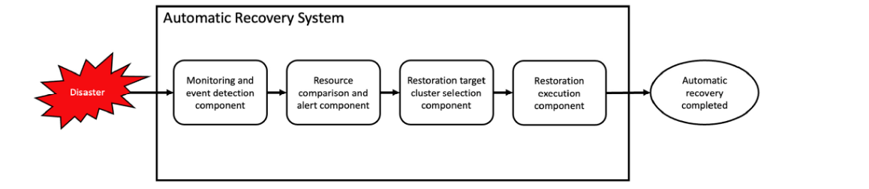
Figure 2.1 Flowchart of the Components of the Automatic Recovery System

Drawbacks and Limitations:
      - The system focuses only on CPU resource prediction, missing other critical components like memory, disk, and network.
      - Requires extensive historical data for model accuracy.
      - Lacks support for multi-cluster Kubernetes environments.
      - Relies heavily on Velero, limiting its flexibility with other backup tools.
      - Model performance depends on the stability of the Prometheus metric streams.

Time Series-Based Kubernetes Autoscaling
Authors - Haibin Yuan, Shengchen Liao
Year Published –2024

Proposed Idea - The paper introduces a time series-based autoscaling solution for Kubernetes clusters using ensemble models like ARIMA, Prophet, and ML algorithms to predict workload spikes. The system provides proactive scaling recommendations to minimize resource waste and improve response times.

Methodology:
      - Prometheus metrics are collected to monitor CPU and memory utilization.
      - Ensemble forecasting using ARIMA, Prophet, and LSTM models is applied.
      - Custom Kubernetes operators are developed for real-time autoscaling.
      - System validates scaling decisions through performance benchmarks.

Architecture:
      - Metric Collection Layer: Real-time Prometheus monitoring.
      - Forecasting Layer: Ensemble time-series prediction models.
      - Autoscaling Layer: Intelligent scaling triggers based on forecasts.
      - Evaluation Layer: Performance monitoring after scaling actions.

Drawbacks and Limitations:
      - The ensemble model requires high computing resources due to the deep architecture.
      - Longer training times may limit real-time applications.
      - Some ECG heartbeat classes lack sufficient training samples, which may affect accuracy for minority classes.
      - Data resampling techniques (like SMOTE) help, but do not fully solve the class imbalance problem.
      - Merging multiple neural networks adds complexity, making hyperparameter tuning more difficult.
      - Requires fine-tuning to prevent model overfitting.

Hybrid Forecasting for Kubernetes Pod Management
Authors - Pasan Bhanu Guruge, Y.H.P.P. Priyadarshana
Year Published –Published in 2025

Proposed Idea - The paper proposes a hybrid model combining Facebook Prophet and LSTM for accurately forecasting pod resource requirements in Kubernetes. The system addresses both seasonality and non-linear resource usage patterns, leading to more accurate pod lifecycle management.

Methodology:
      - The system integrates Facebook Prophet for trend and seasonality decomposition.
      - LSTM is used to model complex, non-linear resource demands.
      - Model is trained using real-time metrics from production Kubernetes clusters.
      - Resource predictions are validated using real-world pod performance.

Architecture:
      - Data Input Layer: Prometheus metrics ingestion.
      - Hybrid Prediction Layer: Prophet + LSTM forecasting.
      - Pod Management Layer: Predictive pod scheduling and scaling.
      - Validation Layer: Forecast accuracy evaluation and adjustment.

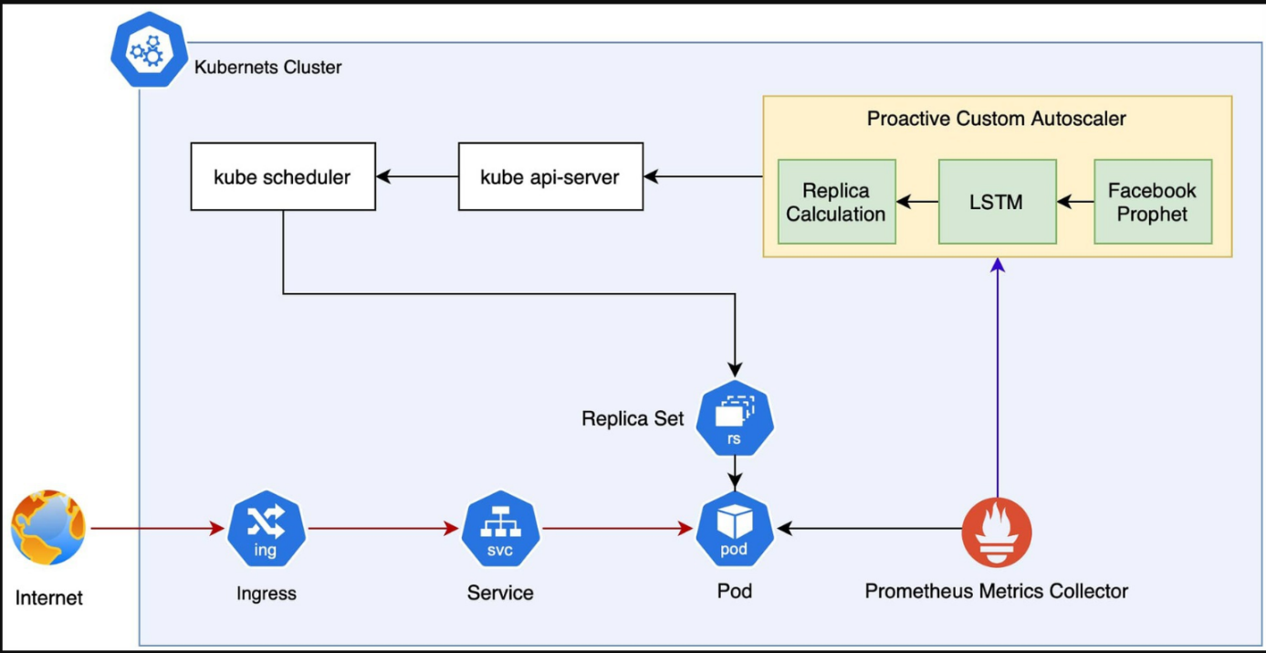

Figure 2.2 System architecture

Drawback and Limitations:
- High computational load due to dual-model architecture.
- Complex integration with Kubernetes horizontal pod autoscaling (HPA).
- Prophet model struggles with rare, abrupt changes in traffic.
- Requires extensive tuning for real-time adaptation.
- Forecasting errors may lead to resource wastage or under-provisioning.

AI-Driven Self-Healing Kubernetes Cluster
Authors - Deepak Kaul
Year Published – 2024

Proposed Idea - The paper presents a self-healing Kubernetes system using unsupervised machine learning for real-time anomaly detection and automated remediation. The system focuses on reducing manual intervention by automating failure recovery.

Methodology:
      - Real-time metrics are streamed from Kubernetes clusters.
      - Unsupervised algorithms detect anomalies without labeled data.
      - Automated remediation actions include pod restarts, resource reallocations, and service rerouting.
      - Model effectiveness is validated using synthetic failure injections.

Architecture:
      - Data Streaming Layer: Prometheus and event log ingestion.
      - Anomaly Detection Layer: Unsupervised ML-based detection.
      - Remediation Layer: Automated healing actions triggered.
      - Feedback Layer: Continuous learning from remediation outcomes.

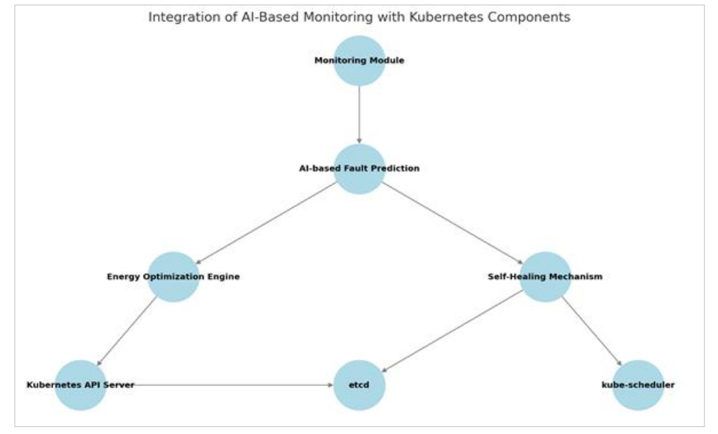

Figure 2.3 Integration of AI-Based Monitoring with Kubernetes Components

Drawbacks and Limitations:
      - Unsupervised models can have high false positive rates.
      - Lack of initial labeled datasets may delay initial accuracy.
      - System requires rigorous testing to avoid triggering incorrect remediation.
      - Not all remediation actions are reversible if misapplied.
      - Network issues and node failures outside Kubernetes remain unaddressed.

Performance Analysis of Anomaly Detection Methods

Authors - Yoichi Matsuo, Daisuke Ikegami

Year Published – 2021

Proposed Idea - The paper analyzes threshold-based, statistical, and ML anomaly detection methods for Kubernetes, focusing on detecting network delays and performance bottlenecks that impact service reliability.

Methodology:
      - Comparative analysis of anomaly detection algorithms in Kubernetes.
      - Real-time detection using both static thresholds and ML-based predictions.
      - Performance benchmarking under varying load and scaling scenarios.

Architecture:
      - Monitoring Layer: Real-time metric ingestion.
      - Detection Layer: Multiple anomaly detection algorithms.
      - Performance Evaluation Layer: Testing system responsiveness under anomalies.

Drawbacks and Limitations:
      - Threshold-based methods lack adaptability to dynamic workloads.
      - ML models require significant training time for accuracy.
      - Difficulty in handling distributed delay issues across clusters.
      - The study does not offer automated remediation solutions.
      - Delay detection effectiveness is sensitive to the chosen detection window.

ML-Based Anomaly Classification in Kubernetes

Year Published – 2022

Proposed Idea - The authors propose machine learning-based anomaly classification for Kubernetes clusters, focusing on classifying anomalies into categories like resource bottlenecks, configuration errors, and application failures.

Methodology:
      - Supervised learning models trained on labeled Kubernetes anomaly datasets.
      - Classification models suggest remediation strategies based on detected anomaly types.
      - Evaluation focused on reducing false positives and improving detection accuracy.

Architecture:
      - Metric Collection Layer: Kubernetes and Prometheus data streams.
      - Anomaly Classification Layer: Supervised ML classification.
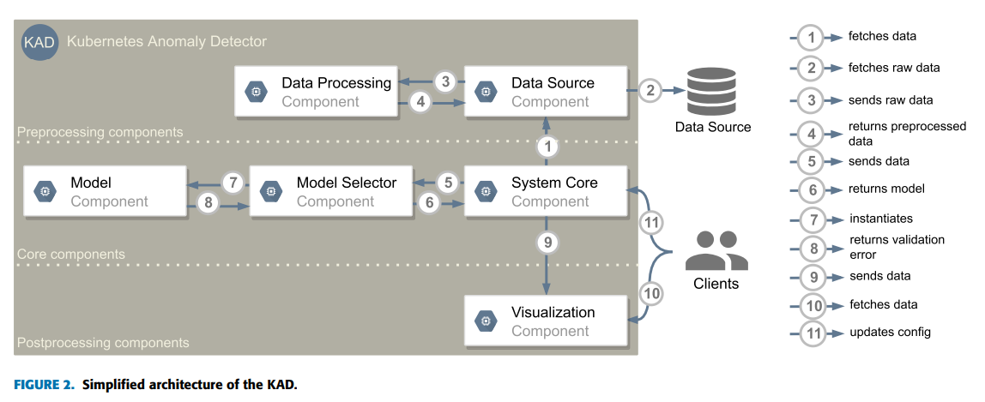
      - Remediation Suggestion Layer: Automated remediation recommendations.
Figure 2.5 Simplified architecture of the KAD

Drawbacks and Limitations:
      - Requires large volumes of high-quality labeled data.
      - Limited performance for detecting unseen anomalies (zero-day failures).
      - Class imbalance affects model accuracy across anomaly categories.
      - Retraining is required frequently as Kubernetes cluster behaviors evolve.

Graph-Based Anomaly Detection for Kubernetes Clusters
Authors - V. Anemogiannis et al.

Year Published – 2025

Proposed Idea - The paper introduces graph-based anomaly detection using Graph Neural Networks (GNNs) to monitor Kubernetes cluster topologies and detect unusual service communication patterns.

Methodology:
      - Kubernetes clusters are modeled as graphs where nodes represent services and edges represent communication links.
      - Graph Neural Networks are used to detect deviations from normal interaction patterns.
      - System focuses on identifying complex, distributed failures.

Architecture:
      - Graph Modelling Layer: Cluster topology mapping.
      - Anomaly Detection Layer: GNN-based detection engine.
      - Response Layer: Alerts generated for detected anomalies.

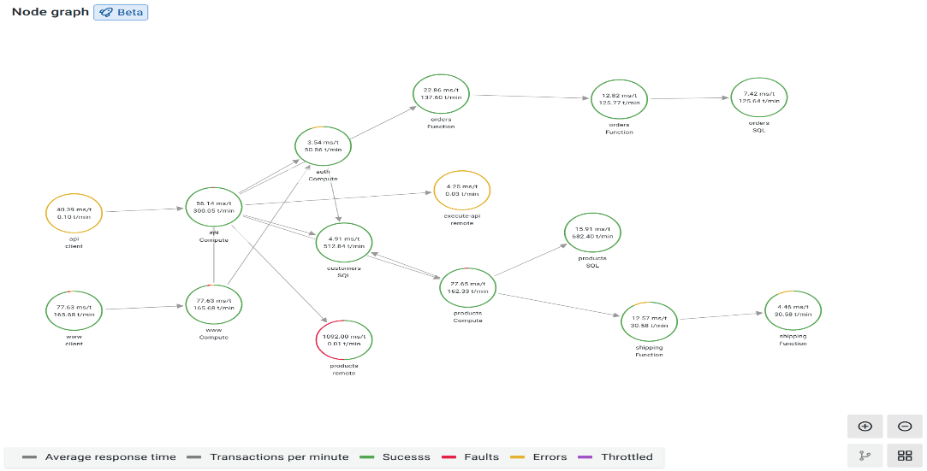

Figure 2.7 Graphana’s Graph Visualization of Monitoring Data

Drawbacks and Limitations:
      - Graph-based models are computationally intensive for large clusters.
      - Real-time graph updates and inference can introduce latency.
      - Requires detailed service-to-service communication mapping.
      - GNN training is complex and data-hungry.
      - Model performance may degrade in multi-cloud and hybrid deployments.

Proactive Autoscaling Using Bidirectional LSTM
Authors - Nhat-Minh Dang-Quang, Myungsik Yoo

Year Published – Published in 2021

Proposed Idea - The paper proposes proactive autoscaling in Kubernetes using Bidirectional LSTM (Bi-LSTM) for better handling of both past and future trends in resource demand.

Methodology:
      - Bi-LSTM models trained on CPU, memory, and request rate data.
      - Prediction used for autoscaling decisions before the system experiences load spikes.
      - Performance validated by reducing response times and improving resource efficiency.

Architecture:
      - Metric Ingestion Layer: Real-time resource monitoring.
      - Bi-LSTM Prediction Layer: Bidirectional LSTM-based forecasting.
      - Autoscaling Layer: Predictive scaling based on forecast results.
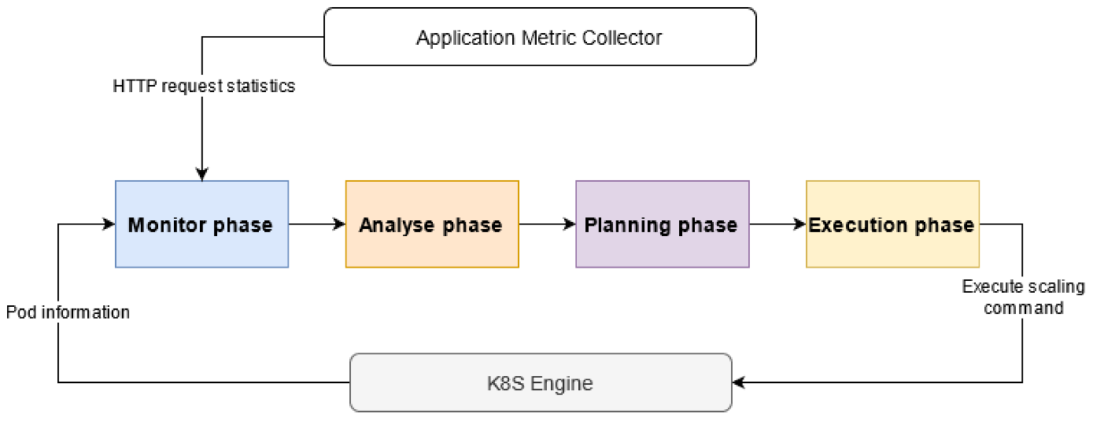
Figure 2.8 Autoscaler architecture

Drawbacks and Limitations:
      - Deep ResNet-50 model has high computational requirements and large model size.
      - Not ideal for real-time or mobile health monitoring systems.
      - Performance evaluation focused on static datasets; real-time validation is missing.

Predictive Maintenance for Kubernetes Microservices
Authors - Charan Shankar Kummarapurugu
Year Published – 2023

Proposed Idea - The paper applies predictive maintenance techniques to Kubernetes-managed microservices by using machine learning to forecast service degradation before failures occur.

Methodology:
      - ML models analyze logs, resource metrics, and service health indicators.
      - Predictions provide 2-4 hour advance warnings of microservice failures.
      - Remediation suggestions are generated based on predicted issues.

Architecture:
      - Data Ingestion Layer: Logs and telemetry collection.
      - Prediction Layer: ML-based failure forecasting.
      - Maintenance Layer: Proactive microservice maintenance recommendations.
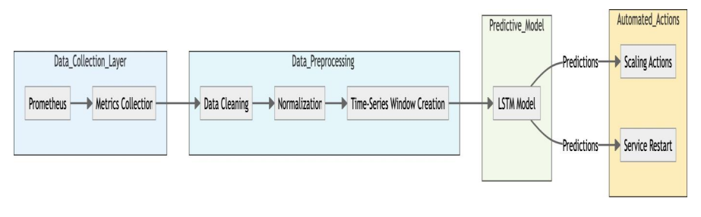

Figure 2.8 System Architecture

Drawbacks and Limitations:
      - Application-specific tuning is required for each microservice.
      - System performance varies across different Kubernetes distributions.
      - Not effective for failures unrelated to resource degradation (e.g., security attacks).
      - Heavy reliance on high-quality logs and metrics.
      - Limited remediation options for complex, multi-service failures.

Drawbacks and Limitations of Existing System

- Manual Reading: Traditional arrhythmia detection still depends on manual analysis by cardiologists, which is time-consuming and error prone.
- Reactive Issue Management: Most traditional Kubernetes monitoring tools rely on reactive approaches, where alerts are triggered only after a problem has occurred, leading to increased downtime and slow recovery.
- Limited Failure Prediction Scope: Many existing systems focus on specific failure types like CPU exhaustion or pod crashes but do not provide comprehensive prediction across memory, network, disk, and multi-cluster issues.
- High False Positive Rates: Anomaly detection systems, especially unsupervised models, often suffer from high false alarms, which can overwhelm DevOps teams and reduce trust in the system.
- Lack of Automated Remediation: Several monitoring frameworks can detect anomalies but do not integrate intelligent, automated remediation workflows, requiring manual intervention to resolve issues.
- Limited Multi-Cluster and Cross-Cloud Support: Most predictive systems are not optimized for managing federated or hybrid Kubernetes clusters, restricting their scalability across global cloud environments.
- Inadequate Handling of Configuration Drifts: Existing tools often miss configuration-related failures and version mismatches, which can lead to service degradation without clear alerts.
- Slow Response Times: Many systems cannot process and react to high-frequency metrics in near real-time, reducing the effectiveness of proactive management.

Problem Statement

Develop an AI and Machine Learning-based system to proactively predict and automatically remediate Kubernetes cluster issues by analyzing real-time metrics, events, and log
Input: CPU, memory, disk, and network metrics from Prometheus.

Output: Predicted Failure Type

Proposed Solution

Dataset Acquisition:
Collect real-time Kubernetes metrics from Prometheus and events from Kubernetes APIs, covering a variety of resource types and failure scenarios.

Signal Preprocessing:
Clean and normalize incoming time-series data to handle missing values, noise, and metric fluctuations using sliding windows and filtering techniques.

Segmentation:
Divide the incoming data into fixed-length time intervals (e.g., 5-minute windows) for consistent input to the prediction models.

Feature Extraction with LSTM and Transformer Models:
Use LSTM and Transformer-based architectures to capture temporal patterns and complex dependencies between cluster resources.

Multi-Model Ensemble:
Combine time-series forecasting, anomaly detection, and classification models using ensemble methods to improve prediction reliability.

Automated Remediation:
Integrate intelligent remediation workflows that automatically trigger actions like scaling, pod restarts, or backups based on predicted issues.

Performance Evaluation:
Evaluate system performance using accuracy, precision, recall, F1-score, Mean Time to Detection (MTTD), and Mean Time to Recovery (MTTR).
Validate the system in both single-cluster and multi-cluster Kubernetes environments.

Chapter 3

REQUIREMENT ENGINEERING

Software and Hardware Tools Used

Software Requirements

Operating System (Windows 10 or above):
The system requires Windows 10 or a modern Linux distribution (e.g., Ubuntu 20.04) to ensure compatibility with Kubernetes tools, Docker, and AI/ML frameworks. These platforms provide a robust and flexible environment for developing and running distributed container-based applications.

Programming Language (Python 3.8+):
Python is selected for its simplicity, scalability, and support for state-of-the-art ML libraries. Version 3.8 or above ensures compatibility with TensorFlow, PyTorch, and other modern frameworks essential for time-series prediction and anomaly detection.

Tools & Libraries (Numpy, Pandas, Matplotlib, Scikit-learn):
NumPy & Pandas are used for efficient data manipulation and preprocessing. Matplotlib aids in visualizing resource usage and prediction trends. Scikit-learn supports traditional ML algorithms for anomaly detection. TensorFlow/Keras or PyTorch are employed for building LSTM/Transformer-based models that forecast Kubernetes failures and resource bottlenecks.

Hardware Requirements

CPU (Intel i5 10th Gen or above):
A multi-core processor ensures efficient handling of concurrent Kubernetes workloads, ML inference, and real-time data processing without bottlenecks.

RAM (16 GB):
Required for running multiple services including Docker containers, Kubernetes cluster (Minikube or K3s), and ML model inference modules simultaneously.

Storage (512 GB SSD):
An SSD with ample capacity enables fast access to logs, container images, and large datasets (e.g., Google Cluster Trace). It also improves training and deployment speed of ML models.

GPU (Intel Iris Xe or higher):
While not mandatory for inference, a dedicated GPU significantly speeds up model training for LSTM and Transformer models. It allows experimentation with larger datasets and models.

Analysis Modelling

Architectural Diagram

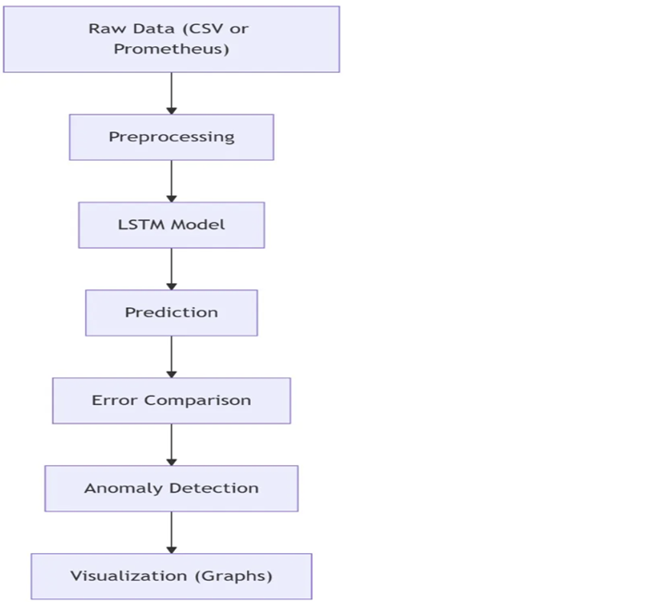

Figure 3.4 Architectural Diagram for Proposed System

The system initiates its process by collecting real-time and historical Kubernetes cluster metrics, which serve as the foundational input for analysis. These metrics include CPU and memory usage, network bandwidth, disk I/O, pod health status, and event logs. The data, typically retrieved using tools like Prometheus or Kubernetes Metrics Server, is structured as multi-dimensional time series sequences. Once collected, the raw metrics undergo preprocessing to ensure consistency and model compatibility. This includes normalizing the values, handling missing data points through interpolation, and structuring the information into fixed-length sliding time windows, commonly spanning 5 to 15 minutes. This temporal segmentation helps in aligning data across different resource dimensions for effective pattern recognition.
Following preprocessing, the data is fed into a deep learning-based feature extraction module. The architecture leverages a combination of one-dimensional convolutional neural networks (Conv1D) and Long Short-Term Memory (LSTM) layers. The Conv1D layers are responsible for extracting localized patterns within the metric sequences, such as sudden CPU spikes or abrupt memory consumption surges. These layers learn spatial features across metrics within short time spans. The output of the Conv1D layers is passed into LSTM layers, which specialize in capturing long-term dependencies and temporal trends. LSTMs are particularly effective in understanding sequential data, enabling the model to detect patterns that precede resource bottlenecks, pod crashes, or service degradations.

The output from the LSTM layers is forwarded to a dense neural layer, which consolidates the extracted features into a compact representation suitable for classification or prediction tasks. The final output of the model may take the form of a class label, indicating a specific type of impending failure, or a continuous value predicting the likelihood or severity of a performance issue within a future time window. The system is designed to identify and classify operational anomalies in categories such as normal behavior, predicted pod crash, node CPU saturation, memory leakage, network congestion, or risk of eviction due to resource exhaustion. These categories enable system administrators to gain actionable insights and understand the root causes of potential disruptions in the cluster.
The predicted outcomes are then visualized through an intuitive dashboard, allowing users to observe trends and understand system health in real-time. When high-risk events are predicted, the system can either recommend corrective actions or automatically execute them, such as restarting failed pods, scaling deployments, or migrating workloads to underutilized nodes. This proactive approach not only minimizes downtime but also enhances the overall resilience and operational efficiency of Kubernetes clusters.

Software Requirements Specification

User Requirements

Cluster Monitoring Dashboard:
The system must provide users (DevOps engineers or administrators) with a web-based interface or dashboard that continuously displays real-time Kubernetes metrics such as CPU usage, memory utilization, node/pod status, and network traffic. The UI should be intuitive and accessible, even for users with limited ML knowledge.

Upload Historical Metrics or Connect to Live Cluster
Upload historical performance logs for offline model evaluation. Connect the system to a live Kubernetes cluster suing APIs for real-time analysis and prediction.

Anomaly Detection & Failure Prediction
The core functionality should allow the user to view predicted issues such as pod crashes, resource bottlenecks, or node failures for the next few minutes (e.g., 5–10 mins). The system should not require manual configuration of ML parameters—predictions must be generated automatically by the integrated models.

Visualize Metrics and Predictions
The system must provide graphical visualization of past and predicted metrics, using line graphs, bar charts, or heatmaps. It should clearly highlight anomalies and the predicted time window in which a failure is expected. Visual markers should indicate which component (e.g., pod, node, namespace) is at risk.

Show Remediation Actions:
Once a potential issue is predicted, the system must display the corresponding recommended or automatically executed remediation action, such as restarting a pod, scaling a deployment, or migrating workloads. The confidence level of the prediction should also be displayed.

System Requirements

Data Processing:
The system must automatically process incoming real-time and historical cluster metrics. This includes collecting resource usage data (CPU, memory, disk I/O, network traffic), pod status, and Kubernetes events from sources like Prometheus and the Kubernetes Events API. Preprocessing involves normalizing time-series data, handling missing values, and structuring the data into sliding windows suitable for ML-based forecasting.

Machine Learning Models:
The system should integrate advanced ML/DL architectures capable of modeling time-series behaviors. This includes models such as Long Short-Term Memory (LSTM) networks for sequential prediction and Transformer models for capturing long-term dependencies and parallel feature learning. These models are used to predict future anomalies or failures, such as pod crashes, node overloads, and traffic spikes.

Result Interpretation:
Model outputs must be presented in a clear and actionable manner. Predictions should be categorized (e.g., “High CPU usage in next 5 mins,” “Probable pod crash”) and accompanied by a confidence score. The system should visualize resource trends using graphs and heatmaps, and provide contextual insights like which service or pod is at risk, and what action is recommended or taken.

Model Evaluation and Reporting:
To ensure reliability and system transparency, the solution must include comprehensive model evaluation. Key performance metrics such as Mean Absolute Error (MAE), Root Mean Square Error (RMSE) for regression models, and Precision, Recall, F1-Score, and Confusion Matrix for classification models must be computed. Evaluation reports should be visualized through dashboards and stored for further analysis.
Chapter 4

PROJECT PLANNING

Project Planning and Scheduling
Project planning and scheduling form a foundational part of the successful execution of this project. The primary goal of this project is to develop an AI and ML-based agent capable of predicting and remediating issues in Kubernetes clusters. Effective planning ensures that each phase of the project—from data acquisition and preprocessing to model development, integration, testing, and deployment—is carried out in a structured and timely manner. It helps in identifying dependencies, allocating resources efficiently, and setting achievable milestones for each task. Moreover, it enables the team to track progress, coordinate responsibilities, and make informed adjustments when needed. By adhering to a well-defined schedule, the project maintains focus on its core objective: delivering a proactive, intelligent system that enhances the resilience and efficiency of Kubernetes-managed cloud infrastructures.

Project Planning

The various modules and their functionalities of our project include:

      - Data Collection & Preprocessing:
This module begins by gathering real-time and historical metrics from Kubernetes clusters using tools such as Prometheus, Kubernetes Metrics Server, and event logs. These raw metrics often contain irregularities such as missing values, noise from transient spikes, and data imbalance. Preprocessing involves normalizing the data, handling missing entries through interpolation, smoothing abrupt anomalies, and segmenting the data into uniform sliding windows—typically of 5 to 15 minutes—for sequential analysis and model training.

Conv1D Feature Extraction Module:
This module employs 1D Convolutional Neural Networks to extract localized patterns in resource usage metrics, such as sudden CPU spikes, memory leaks, or bandwidth surges. The Conv1D layers identify short-term trends across time-series inputs from nodes, pods, or namespaces. Layers in this module typically include convolution operations, activation functions like ReLU, pooling layers to reduce dimensionality, and dropout layers for regularization to prevent overfitting.

LSTM Temporal Analysis Module:
The output of the convolutional layers is passed into Long Short-Term Memory (LSTM) networks, which are designed to learn long-term dependencies in sequential data. This module analyzes how resource consumption evolves over time, identifying slow-building anomalies or repeating failure signatures. This temporal analysis is critical for predicting failures such as pod eviction, node exhaustion, or cluster instability before they occur.

Performance Evaluation:
The system’s predictive accuracy is assessed using both regression and classification metrics. Evaluation includes Mean Absolute Error (MAE) and Root Mean Square Error (RMSE) for forecast-based models, and precision, recall, F1-score, and confusion matrices for classification-based outputs. These metrics help understand the model’s robustness, especially in identifying early-stage failures and differentiating between types of issues.

Dashboard or Web Interface:
A user-friendly interface is developed to display cluster health, metric trends, and prediction outcomes. Users can interact with a live dashboard to visualize data, receive real-time alerts, and view suggested or executed remediation actions. Frameworks like React, Flask, or Grafana may be used to create interactive and visually rich dashboards for both technical and non-technical users.

Integration & Testing:
All components are integrated into a cohesive pipeline that can operate on both historical datasets and live clusters. Unit testing ensures each component functions correctly in isolation, while integration testing validates the full workflow—from data ingestion and prediction to remediation. The system is stress-tested using various simulated workloads and fault conditions to ensure its reliability, responsiveness, and ability to handle real-time cluster dynamics.

Chapter 5
APPLICATIONS & CONCLUSION

  - Applications

- Proactive Infrastructure Management: By continuously analyzing cluster metrics over time, the AI/ML system can detect unusual patterns and predict failures before they occur. This enables infrastructure teams to maintain system health proactively rather than reactively, reducing downtime and improving reliability.
- Real-time Failure prediction: Integrated within cloud environments, the system can process streaming Kubernetes metrics to identify potential pod crashes, CPU saturation, or memory leaks in real time. This helps organizations respond to threats within seconds, rather than after users are impacted.
- Automated Remediation: The model's predictions can trigger automated corrective actions, such as restarting failed pods, autoscaling deployments, or rescheduling workloads on healthier nodes. This reduces the need for manual intervention and speeds up recovery.
- Cost Optimization: By predicting when workloads will require additional resources—or when resources are underutilized—the system can help optimize cloud resource allocation, reducing infrastructure costs without compromising performance.
- Scalability in Production Environments: In large-scale deployments with hundreds or thousands of services, manual monitoring is impractical. This system ensures that scalable, intelligent cluster management is possible, even in highly dynamic microservices architectures.

Conclusion

The prediction and remediation of failures in Kubernetes clusters is a critical aspect of maintaining the reliability, scalability, and efficiency of modern cloud-native applications. As clusters grow in complexity and scale, traditional monitoring tools often fall short due to their reactive nature and reliance on static thresholds. This project demonstrates how deep learning techniques—particularly convolutional and recurrent neural networks—can be harnessed to anticipate anomalies and proactively manage infrastructure health.
By automating both the prediction of failures and the execution of remediation actions, the proposed system reduces the burden on DevOps teams and minimizes the risk of human error in critical production environments. Through the use of publicly available datasets, such as the Google Cluster Trace, combined with thorough preprocessing and rigorous evaluation of ML models, this work showcases the potential of AI in intelligent system management.
The results indicate that deep learning models can effectively learn and generalize complex patterns in resource usage and system behavior, offering a scalable, real-time solution for dynamic cluster environments. This project not only addresses immediate operational challenges but also lays the groundwork for future developments, including self-healing infrastructures, adaptive autoscaling strategies, and fully autonomous cloud platforms capable of maintaining service-level objectives without human intervention.

REFERENCES
[1] J.-B. Kim, J.-B. Choi, and E.-S. Jung, “Design and implementation of an automated disaster-recovery system for a Kubernetes cluster using LSTM,” Applied Sciences, vol. 14, no. 3, p. 3914, 2024.
[2] J. Kosińska and M. Tobiasz, “Detection of cluster anomalies with ML techniques,” IEEE Access, vol. 10, pp. 108662–108673, 2022.
[3] A. Verma, L. Pedrosa, M. Korupolu, D. Oppenheimer, and E. Tune, “Large-scale cluster management at Google with Borg,” in Proceedings of the European Conference on Computer Systems (EuroSys), pp. 1–17, ACM, 2015.
[4] R. Grandl, G. Ananthanarayanan, S. Kandula, S. Rao, and A. Akella, “Multi-resource packing for cluster schedulers,” ACM SIGCOMM Computer Communication Review, vol. 44, no. 4, pp. 455–466, 2014.
[5] H. Hindy, D. Brosset, E. Bayne, C. Bellekens, and A. Seeam, “A taxonomy and survey of intrusion detection system design techniques, network threats and datasets,” arXiv preprint, arXiv:1806.03517, 2018.
[6] A. Kephart and D. Chess, “The vision of autonomic computing,” Computer, vol. 36, no. 1, pp. 41–50, 2003.
[7] T. Mikolov, M. Karafiát, L. Burget, J. Černocký, and S. Khudanpur, “Recurrent neural network-based language model,” in Interspeech, pp. 1045–1048, 2010.
[8] S. Hochreiter and J. Schmidhuber, “Long short-term memory,” Neural Computation, vol. 9, no. 8, pp. 1735–1780, 1997.
[9] B. Burns, B. Grant, D. Oppenheimer, E. Brewer, and J. Wilkes, “Borg, Omega, and Kubernetes: Lessons learned from three container-management systems over a decade,” Communications of the ACM, vol. 59, no. 5, pp. 50–57, 2016.
[10] H. Chen, W. Li, L. Ouyang, Y. Sun, and Z. Zhou, “AIOps-based anomaly detection for cloud-native environments,” in 2020 IEEE International Conference on Cloud Computing Technology and Science (CloudCom), pp. 188–193, IEEE, 2020.

